Mr. Visca – AP Calculus AB

Unit 3: derivatives Review Notes

**Definition of Derivative:**

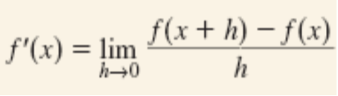

**Notation:**

y’ f’(x) $\frac{dy}{dx}$ $\frac{d}{dx}f(x)$

**Where differentiability (derivatives) don’t exist, even though function is continuous…**

Corner, Cusp, Vertical Tangent Line, or any discontinuity

FYI…if a function is differentiable, it MUST be continuous (the reverse is not always true)

Calculator Help: math, 8 = nDeriv

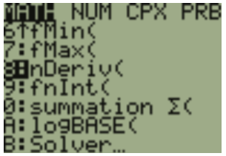

**Derivative Rules:**

Derivative of a constant

Basic Power Rule

Product Rule

Quotient Rule

Find the equation of the tangent line to the curve $y=\frac{x^{2}+3}{2x}$ at the point (1, 2).

How do you find the second derivative?

y’’ f’’(x) $\frac{d^{2}y}{dx^{2}}$ $\frac{d}{dx}f'(x)$

**Position vs Velocity vs Acceleration:**

A particle moves along a line so that its position at any time is s(t) = t2 - 4t + 3. (s in meters and t in seconds).

a) Find the displacement of the particle during the first 2 seconds?

b) Find the average velocity during the first 4 seconds?

c) Find the instantaneous velocity at t=4?

d) Find the acceleration at t=4?

e) Is the particle speeding up or slowing down at 4 seconds?

f) At what value of t does the particle change directions?

**Derivatives of Trig ☺ (“Do your chain hang low? Do it wobble to the flo’? Do it shine in the light? Is it platinum, is it gold?” - Jibbs)**

$\frac{d}{du}(\sin{u)}$ = $\frac{d}{du}(\csc{u)}$ =

$\frac{d}{du}(\cos{u)}$ = $\frac{d}{du}(\sec{u)}$ =

$\frac{d}{du}(\tan{u)}$ = $\frac{d}{du}(\cot{u)}$ =

We are ALWAYS doing the ___________________ rule…whether we realize it or not!

An object moves along the x-axis so that its position at any time, t ≥ 0, is given by

x(t) = cos(t2+1). Find the velocity and acceleration of the object as a function of t.

Find the derivative of g(t) = tan(5 - sin2t)

**Implicit Differentiation**

When you can’t get “y =” alone

Take the derivative of x and y, except, when you take the derivative of y, you need to put

__________________________________ next to it

Ex. Find the equation of the tangent line to the ellipse x2 - xy + y2 = 7 at the point (-1, 2).

Find y'' if 2x3 - 3y2 = 8

**Derivatives of INVERSES**

$\frac{df^{-1}}{dx}$ or $\frac{d}{dx}f^{-1}(x)$

=

If S is the inverse function of f, if f(x) = x3 + x, find S’(2)

**Derivatives of Trig Inverses:**

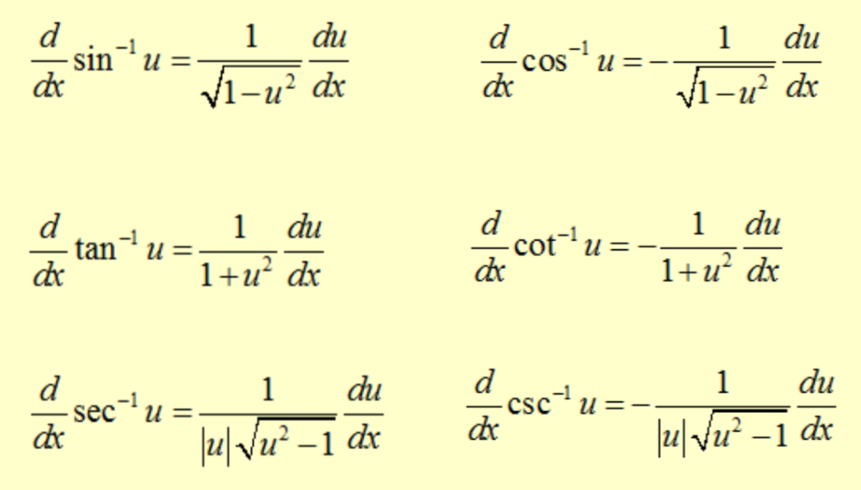

**Derivatives of Exponentials and Logs**

$$\frac{d}{dx}e^{u}=$$

$$\frac{d}{dx}\ln{u}=$$

$$\frac{d}{dx}a^{u}=$$

$$\frac{d}{dx}\log_{a}{u}=$$

Part 1: No Calculator Allowed Chapter 3 Review

Show all your work!

1. If , find .

2. If , then 

3. If , then 

4. Explain why each graph below is not differentiable at x = 0.

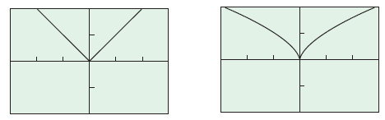

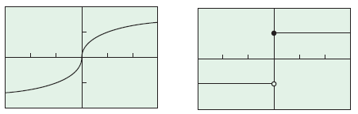

5. If , then 

6. The is

7. If , find .

8. Find the slope of the tangent to the curve  at the point (3, 4).

9. 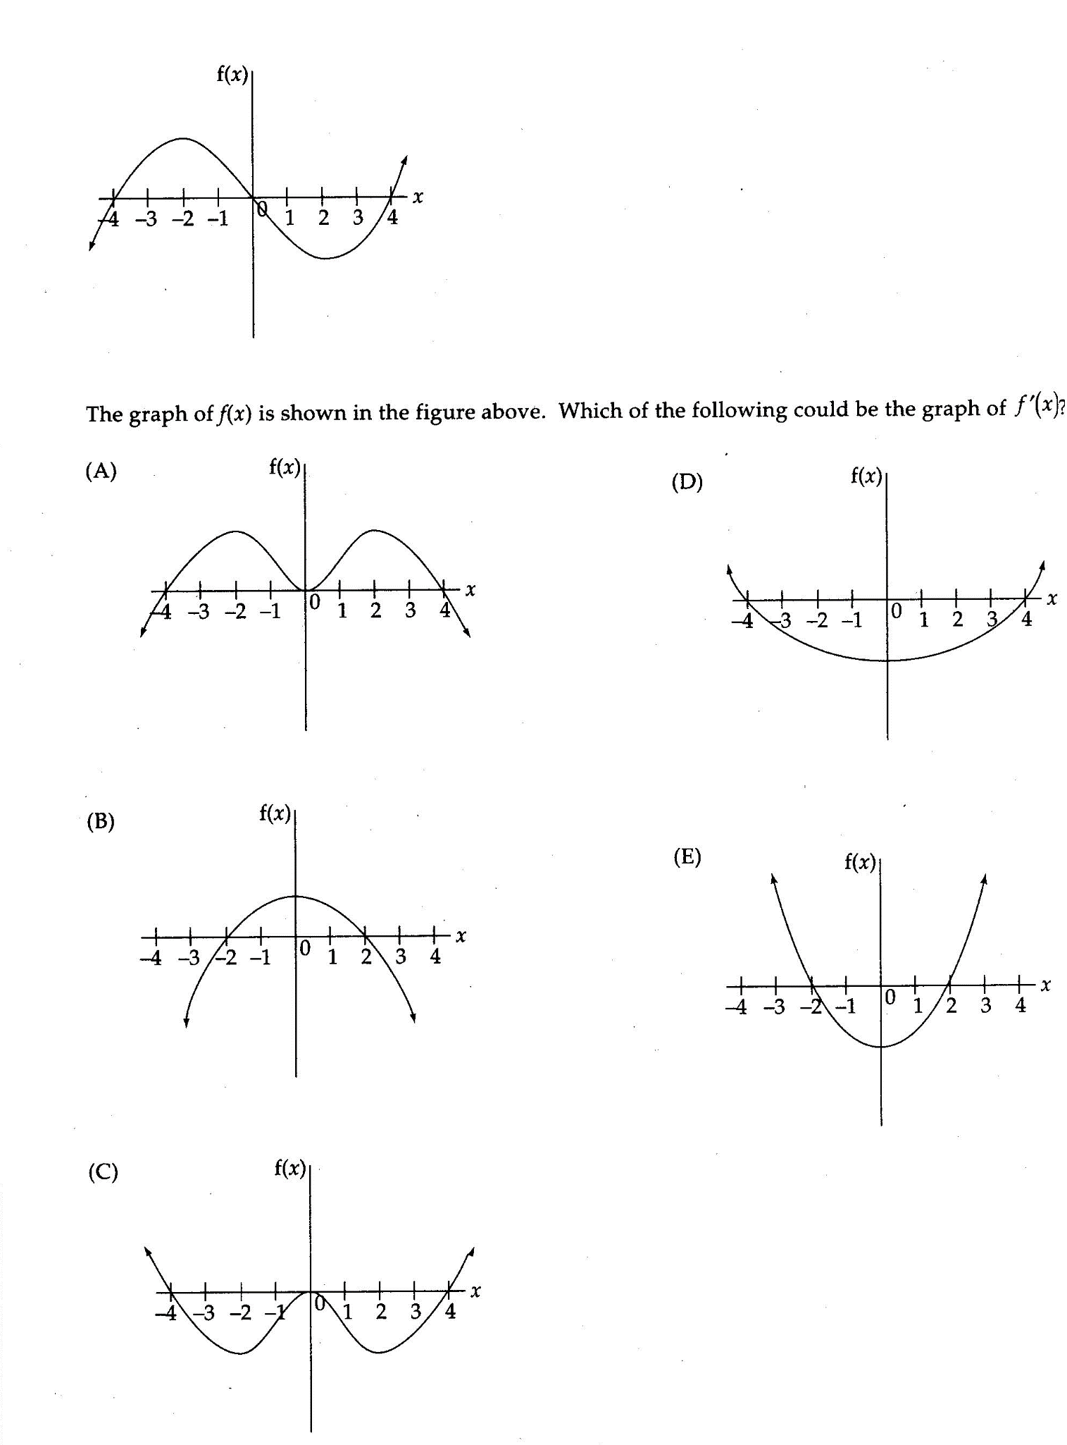

Part 2: Graphing Calculator Required Chapter 3 Review

Show all your work!

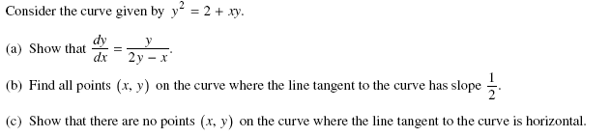10.

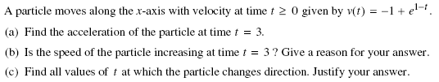11.

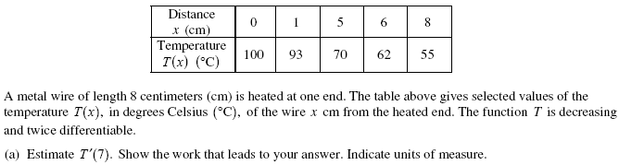12.

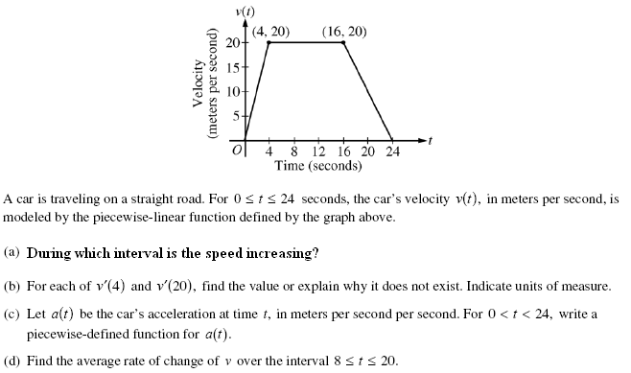

13.